- The Monetary Policy Committee voted 8-1 to cut Bank Rate by 25bps to 4.75% at its November meeting. The MPC maintained its core message that rates will be cut at a gradual pace, and we will stick with our forecast that the 'cut-hold' tempo will be maintained in the near-term.
- Market expectations for Bank Rate at end-2025 have risen by nearly 50bps since the MPC's forecast was locked, reflecting the impacts of the October Budget and US election. But with the MPC forecasting 2% inflation over the medium-term, its implicit message is that if the outlook turns out roughly as expected, rates will probably fall faster than current market pricing implies.
- We maintain our baseline forecast that the MPC will cut Bank Rate by 100bps in 2025. This is the same pace implied by the market curve underpinning the MPC's inflation forecast.
- The medium-term outlook for rates is more uncertain. We see a risk that a more volatile global backdrop will lift inflation expectations, implying Bank Rate will stay higher for longer.
The Bank of England's Monetary Policy Committee voted 8-1 to cut Bank Rate by 25bps to 4.75% at today's meeting. When the committee first cut rates in August, Huw Pill and Megan Greene joined Catherine Mann in voting against. But today Pill and Greene joined the majority in supporting looser policy.
The MPC again set out three scenarios with varying degrees of inflation persistence. For the first time, the MPC explicitly tied its central forecast to the mid-range scenario, which assumes the second-round effects on domestic prices and wages dissipate more slowly than they emerged. This forecast shows CPI inflation dropping back to the 2% target over the medium-term (Chart 1), based on market interest rate expectations that Bank Rate will fall by around 100bps to 3.75% by the end of next year.
Compared with August, the new inflation forecast was lower in the short-term because recent data has been softer than expected. But the new projection is higher from mid-2025 onwards, largely due to the impact of last week's Budget. The BoE's provisional estimates suggest a boost to GDP next year of 0.75ppts.
Chart 1: The boost to demand from the Budget has pushed up the MPC's inflation forecast
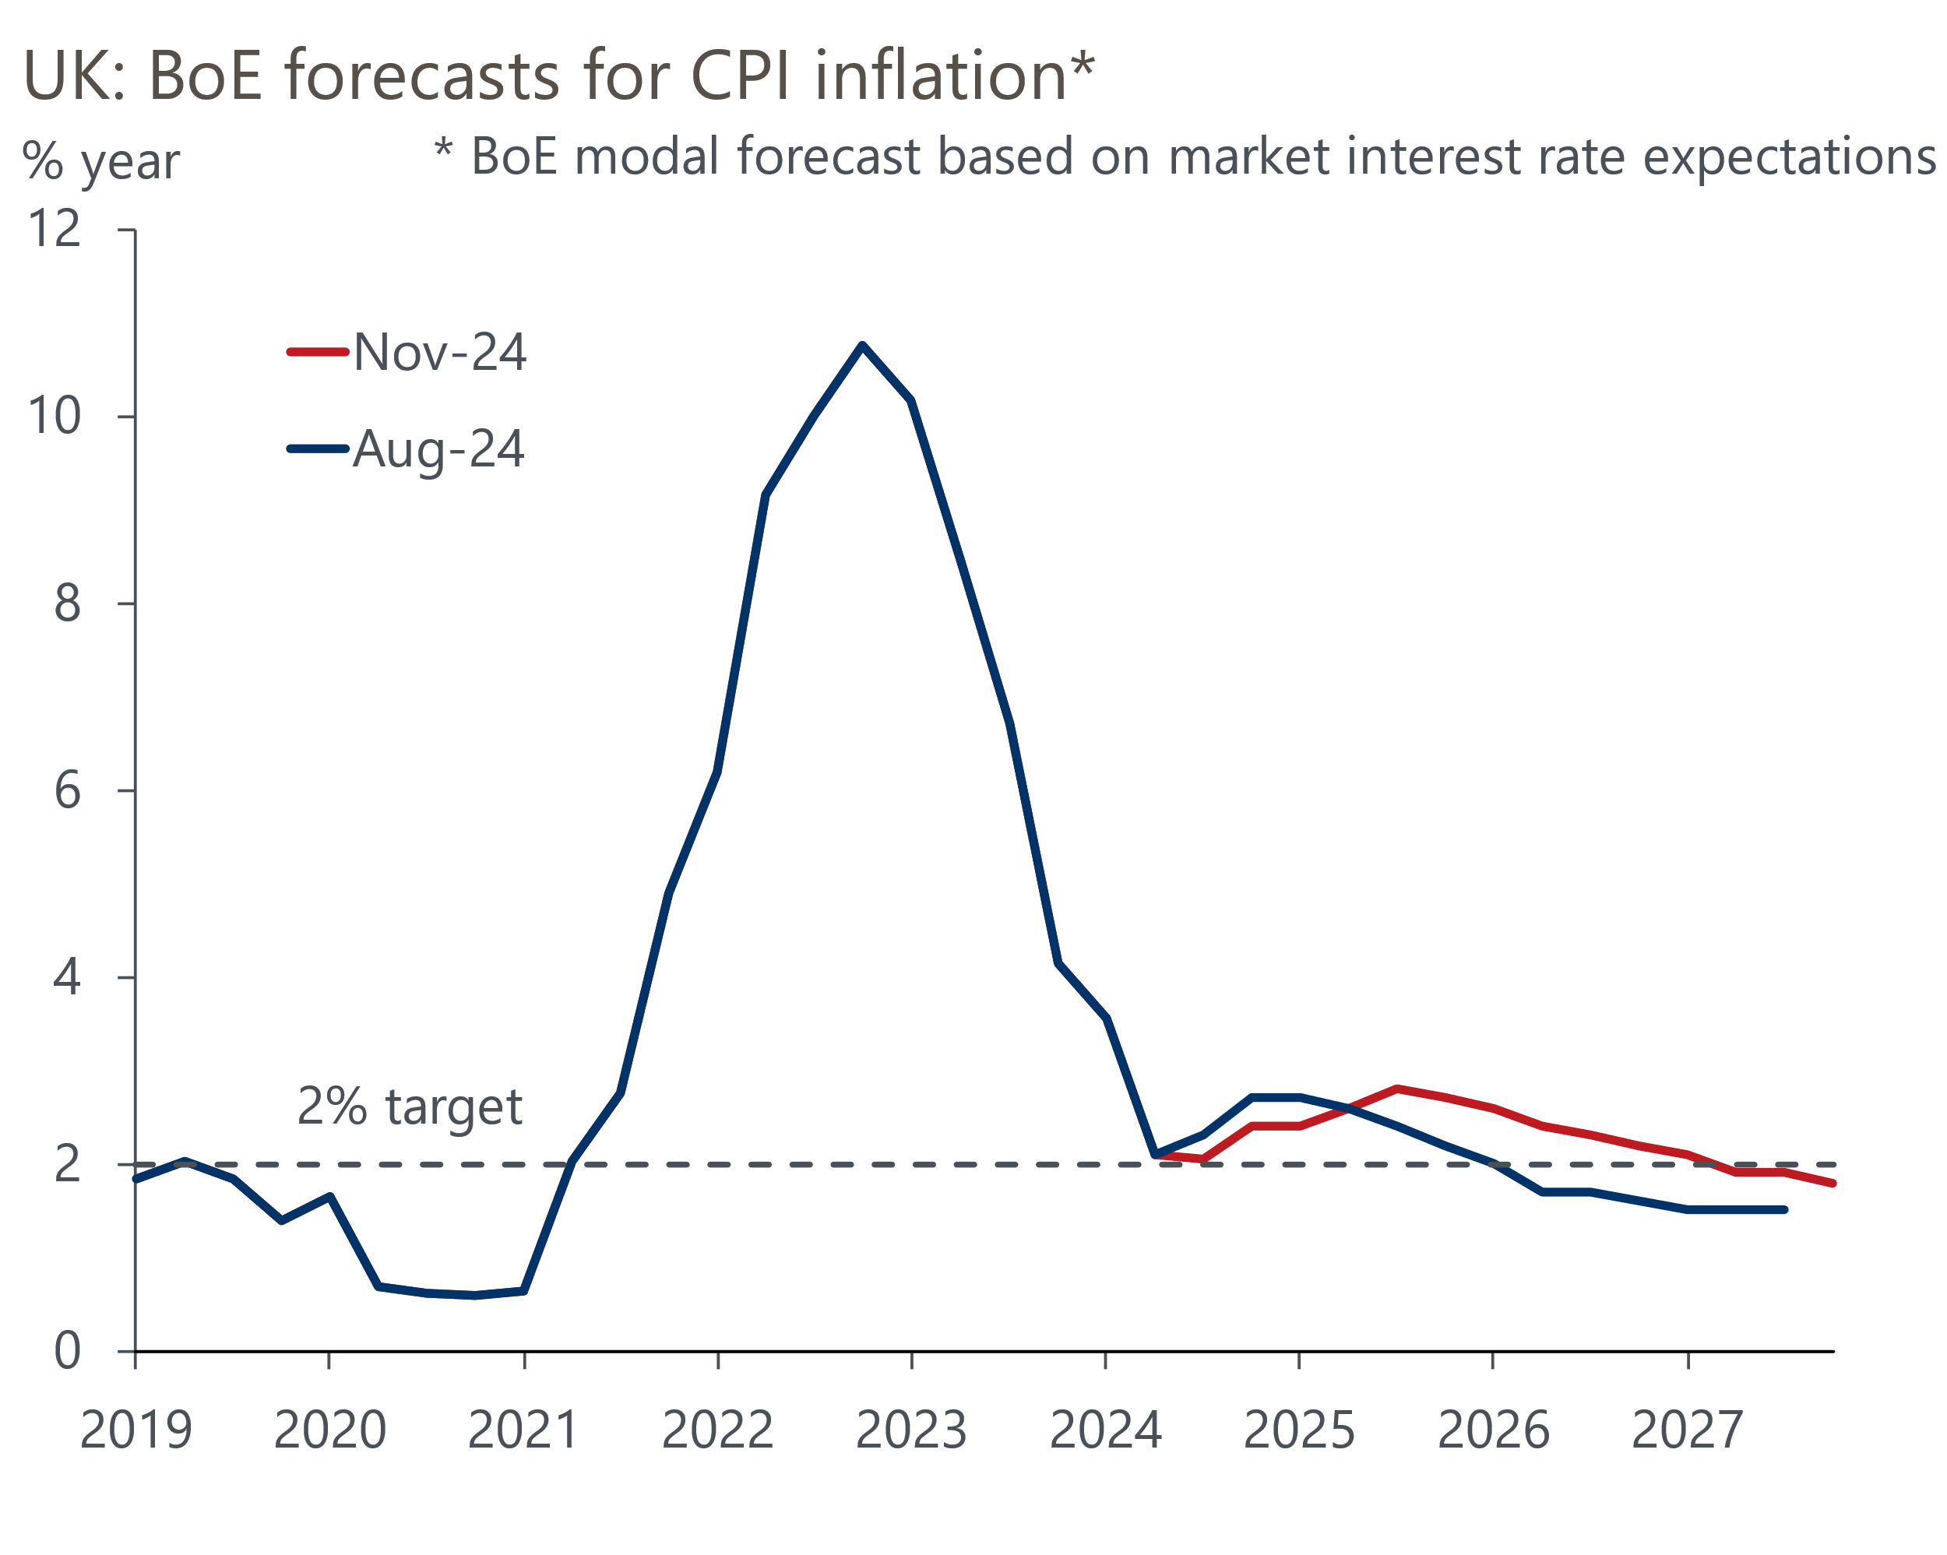
Source: Bank of England Monetary Policy Report

As with the OBR's analysis, we think the BoE's estimate of the Budget impact will prove too optimistic. But its August forecasts for GDP growth over the next two years were very low, so today's revisions have brought their projections close to our own forecast (Chart 2). Similarly, the BoE's previous forecast implied that a sizeable amount of spare capacity would emerge over the medium-term. Therefore, the Budget-related changes merely prevent this slack from emerging, rather than implying renewed inflationary pressures.
Chart 2: The BoE's upgrade brings its forecast broadly into line with our post-Budget forecast
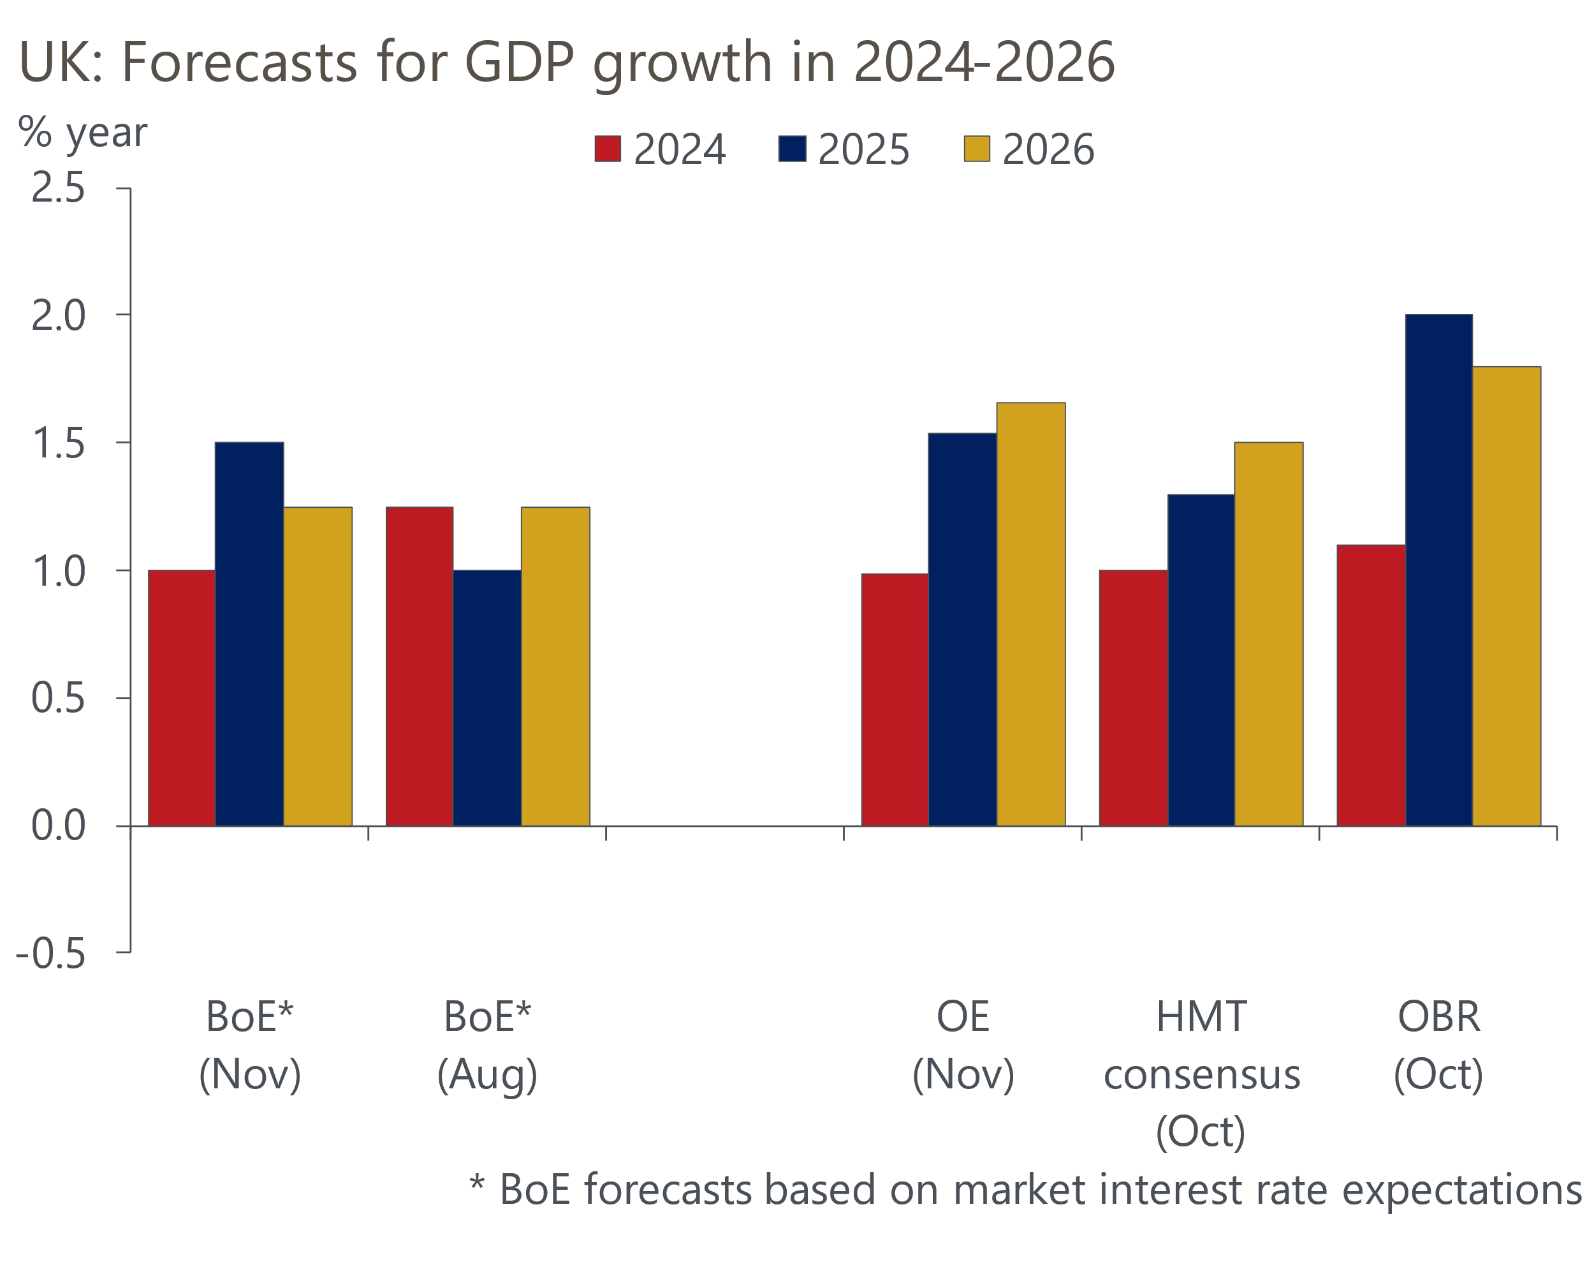
Sources: Oxford Economics, BoE, HMT, OBR
The new projection included higher assumptions for import prices, but this was offset by softer domestic pressures. This is consistent with the majority of the committee believing that the growth/inflation trade-off has improved, and that while the mid-range scenario is the most likely to play out, the risks are tilted towards the more benign variant. The MPC's confidence that underlying pressures are continuing to soften will have been bolstered by the survey of the BoE's regional agents, which reported that firms expected early-2025 pay settlements to be in the 2%-4% range.
The elephant in the room was the fact that markets have repriced significantly since the MPC locked its conditioning assumptions. The MPC's forecasts were based on average market interest rate expectations over the 15 days to October 29, the day before the Budget. As of market close yesterday, expectations for Bank Rate at the end of 2025 were nearly 50bps higher than the level used in the Monetary Policy Report (Chart 3).
Chart 3: Market pricing has moved significantly since the BoE locked its assumptions
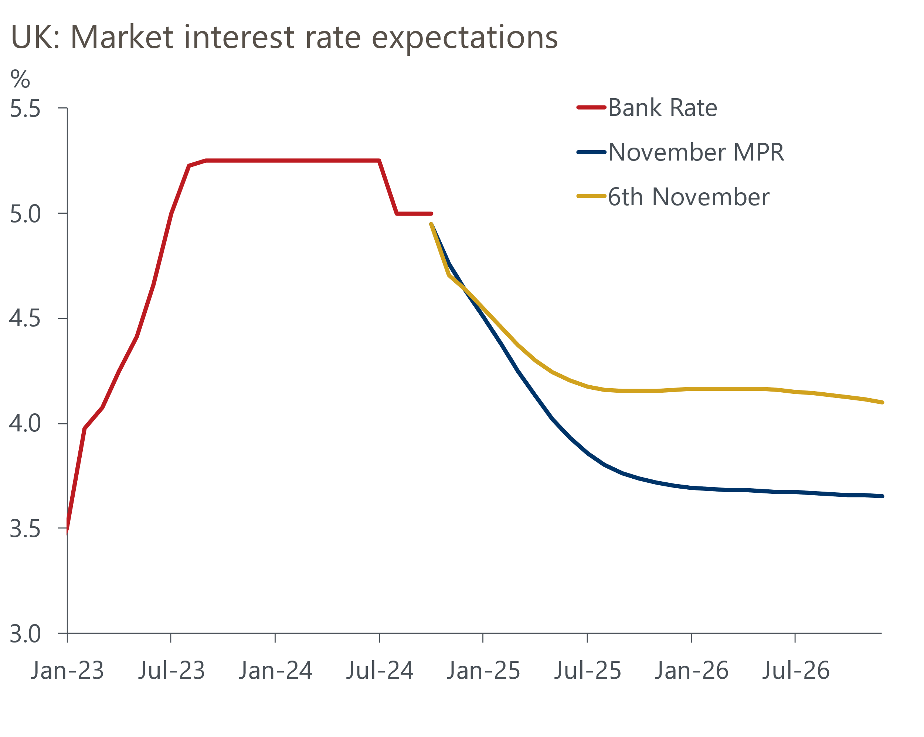
Source: Haver Analytics
In the press conference, Governor Andrew Bailey said that the repricing reflected both the Budget and the US election. Bailey chose not to push back against recent market moves. But given that the BoE's forecast of 2% inflation over the medium-term already incorporates the demand boost from looser fiscal policy, there's a clear implication that the MPC expects to loosen policy more quickly than current market pricing suggests.
Coming into this meeting, we were looking for any indications that the MPC might deviate from the cut-hold pattern that's becoming established, and might cut again in December. There were hints that the MPC believes the inflation/growth trade-off is continuing to improve. But with the forecast being explicitly tied to the mid-range scenario and the minutes not offering any benchmarks against which the MPC might judge that the scenario probabilities are changing, there's no apparent urgency to switch up the tempo. Two further inflation and labour market releases are due before the December meeting, but given current hawkish market sentiment, the bar to these releases encouraging the MPC to cut again at that meeting looks very high.
We are sticking with our baseline forecast that the MPC will cut Bank Rate by 100bps next year, ending 2025 at 3.75%. This is consistent with our new global forecast, which adopts our 'limited Trump' scenario. This assumes looser US fiscal policy and targeted tariffs, with tighter US monetary policy than we previously anticipated in response. But we've consistently argued that the Fed's influence on central banks in other advanced economies is overstated. Meanwhile, under this scenario, the effects of a Trump presidency on UK domestic activity and inflation in the near term are likely to be too small to have much impact.
Still, the outlook for the medium-term looks less clear. A more volatile global backdrop might cause inflation expectations to rise again, leading the MPC to tilt back towards its more hawkish inflation scenario. If this scenario begins to play out, then we would expect to see Bank Rate remain higher for longer.

Key passages from the MPC minutes
“At this meeting, eight members preferred to reduce Bank Rate to 4.75%. There had been continued progress in disinflation, particularly as previous external shocks had abated, although remaining domestic inflationary pressures were resolving more slowly. These members put different probabilities on and risks around the three cases, but they believed that a cut in Bank Rate was appropriate at this meeting. They would continue to assess the range of evidence over time."
Our interpretation: The paragraph summing up the opinion of the majority hints at a range of views, but it offered very little detail. Equally there was no indication about what members are looking for in the incoming data to judge whether the central scenario remains the most likely outcome.
"One member preferred to maintain Bank Rate at 5%. For this member, structural factors in wage and price-setting dynamics continued to draw out the underlying disinflation process, and CPI inflation was projected to remain above the 2% target until the end of the forecast period. Wage developments might continue to be more robust than projected as firms and workers incorporated past and upcoming adjustments in the National Living Wage and National Insurance contributions. This, along with prospects for more robust demand associated with the Budget, was likely to support pricing opportunities for firms. In the face of these uncertainties, maintaining the current level of Bank Rate would allow time to evaluate whether these upside pressures would materialise."
Our interpretation: Catherine Mann continues to lean toward the MPC's more hawkish scenario, with the Budget adding to her concerns about the risk of underlying inflation pressures remaining too strong. It's unlikely that she will support looser policy any time soon, but she appears to be an increasingly fringe voice on the committee, given that Pill and Greene voted to cut rates at this meeting.
"Based on the evolving evidence, a gradual approach to removing policy restraint remained appropriate. Monetary policy would need to continue to remain restrictive for sufficiently long until the risks to inflation returning sustainably to the 2% target in the medium term had dissipated further. The Committee would continue to monitor closely the risks of inflation persistence and would decide the appropriate degree of monetary policy restrictiveness at each meeting."
Our interpretation: This was a similar formulation to previous months. It emphasises that policy is still restrictive, so there is space for rate cuts, but that the pace of rate cuts will be gradual.

